

Report of Machine Learning and
Data Analysis Practice

Group Number : 6
Student ID | Name | Email | College / School
202203151117 | 马晨烨 | 915013326@qq.com | 浙江工业大学
202103150215 | 阮扬程 | 1078397308@qq.com | 浙江工业大学
GJH20240111 | 秦睿思 | 1038469812@qq.com | 安徽工业大学
202205110621 | 吴菲涵 | 1613219346@qq.com | 浙江工业大学
202203150127 | 杨潇林 | 2169507042@qq.com | 浙江工业大学

Contribution of Each Member in the Group Work
Student Name | Description of Main Duty in the Teamwork | Overall Contribution Percentage（%）
马晨烨 | Responsible for task assignment and part of the code writing debugging | 20
阮扬程 | Responsible for writing ppt and providing part of the codes | 20
秦睿思 | Responsible for making a presentation and writing part of the codes | 20
吴菲涵 | Responsible for polishing the ppt and writing part of the codes | 20
杨潇林 | Responsible for Verification comparison and writing part of the codes | 20

CONTENTS
1. Practice on BikeBuys Dataset 1
1.1 Business Understanding 1
1.2 Data Understanding and Exploratory Data Analysis 1
1.2.1 Description of Dataset 1
1.2.2 Exploratory Data Analysis 1
1.2.3 Feature Engineering 3
1.3 Machine Learning Process 5
1.3.1 Data Preparation and Data Processing 5
1.3.2 Model Selection and Performance Analyze 6
1.3.2.1 Linear regression 7
1.3.2.2 Logistic regression 11
1.3.2.3 KNN 14
1.3.2.4 Tree-based model 16
1.3.2.5 Gradient Boosting Trees 19
1.3.2.6 K-Means 22
1.3.2.7 DBSCAN 24
1.3.2.8 Random Forest 26
1.3.2.9 AdaBoost 28
1.3.2.10 PCA 32
1.3.3 Model Evaluation and Performance Analysis 33
1.3.4 Model Improvement or Optimization 36
2. Practice on Zombie enterprise Dataset 40
2.1 Business Understanding 40
2.2 Data Understanding and Exploratory Data Analysis 41
2.2.1 Description of Dataset 41
2.2.2 Exploratory Data Analysis 41
2.2.3 Feature Engineering 45
2.3 Machine Learning Process 46
2.3.1 Data Preparation and Data Processing 46
2.3.2 Model Selection and Performance Analyze 48
2.3.2.1 KNN 48
2.3.2.2 Logistic Regression 50
2.3.2.3 LDA 52
2.3.2.4 Random Forest 54
2.3.2.5 Adaboost 57
2.3.3 Model Evaluation and Performance Analysis 60

1. Practice on BikeBuys Dataset

1.1 Business Understanding
Through the given data, data cleaning and machine learning models are built to classify shoppers' consumption types. Given that there are nine categories of people who buy bicycles, we can categorize those who intend to purchase a bicycle and make further arrangements based on actual conditions, so as to provide reasonable recommendations and increase the likelihood of them making a purchase.

1.2 Data Understanding and Exploratory Data Analysis

1.2.1 Description of Dataset
The dataset contains information about potential bike buyers, including their unique identifiers (ProspectiveBuyerKey, ProspectAlternateKey) and personal details such as first name, middle name, last name, birthdate, marital status, gender, and email address.We will classify the data columns into character types,such as Education,Occupation,gender and number types,such as YearlyIncome,TotalChildren,NumberChildrenAtHome,HouseOwnerFlag and NumberCarsOwned. Deal with them separately.
We want to predict the quantity by analyzing the relationship between different columns of information and the quantity purchased,And classify the characteristics of buyers.

1.2.2 Exploratory Data Analysis
In this part, we classify the column of YearlyIncome into different annual income levels, and also classify the column of purchasers' TotalChildren. It can be seen that the number of purchasers with different number of children in a family is also different
- # 划分收入层次
- def categorize_income(income):
- if 10000 <= income <= 30000:
- return '10000-30000'
- elif 30000 < income <= 60000:
- return '30001-60000'
- elif 60000 < income <= 90000:
- return '60001-90000'
- elif 90000 < income <= 120000:
- return '90001-120000'
- else:
- return 'Out of Range' # 处理不在指定范围内的收入

- # 应用分类函数 YearlyIncome
- df['IncomeCategory'] = df['YearlyIncome'].apply(categorize_income)

- # 统计每个类别的数量
- income_category_counts = df['IncomeCategory'].value_counts().sort_index()

- # 绘制柱状图
- plt.figure(figsize=(10, 6)) # 设置图形大小
- income_category_counts.plot(kind='bar')
- plt.xlabel('Income Category')
- plt.ylabel('Number of Individuals')
- plt.title('Income Distribution by Category')
- plt.xticks(rotation=45, ha='right') # 旋转x轴标签，以便更好地显示
- plt.tight_layout() # 自动调整子图参数，使之填充整个图像区域
- plt.show()

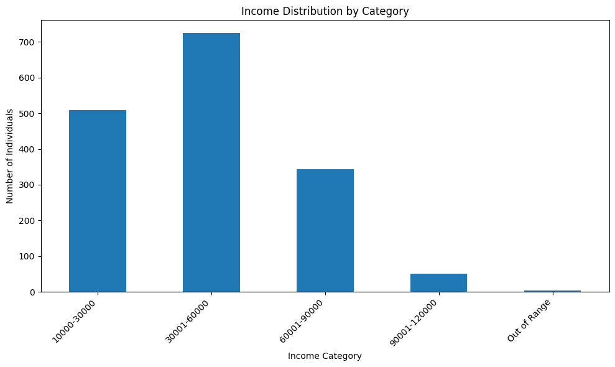
图 1 Income stratification
- # 将日期时间数据转换为出生年份
- child_counts = df['TotalChildren'].value_counts()

- # 生成柱状图
- ax=child_counts.plot(kind='bar')
- plt.xlabel('TotalChildren')
- plt.ylabel('Number')
- plt.title('Bicycle buyers are classified according to their TotalChildren')

- for i, v in enumerate(child_counts):
- ax.text(i, v + 2, str(v), color='black', ha='center')
- plt.show()

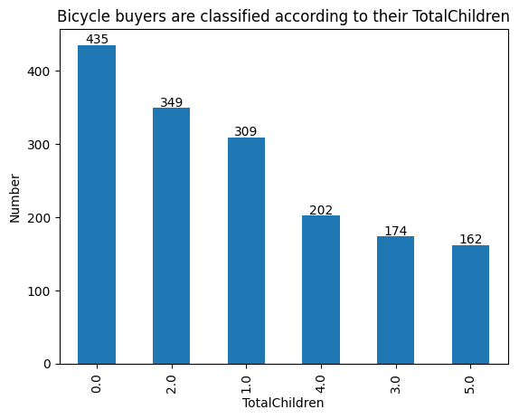
图 2 TotalChildren stratification

1.2.3 Feature Engineering
First, we encode the Category column as numbers. Through correlation analysis of the data in the table, we draw a heat map, through which we can find the 5 variables most related to Category, which is convenient for us to train the model later
- # 创建LabelEncoder实例
- label_encoder = LabelEncoder()

- # 对'Category'列进行标签编码
- df['Category_encoded'] = label_encoder.fit_transform(df['Category'])

- # 确保'Category_encoded'列是整数类型
- df['Category_encoded'] = df['Category_encoded'].astype('int64')

- numeric_data = df.select_dtypes(include=['int64', 'float64'])
- spearman_corr = numeric_data.corr(method='spearman')
- print(spearman_corr)

- plt.figure(figsize=(10, 8))

- # 使用seaborn绘制热图
- sns.heatmap(spearman_corr, annot=True, cmap='coolwarm')
- plt.show()
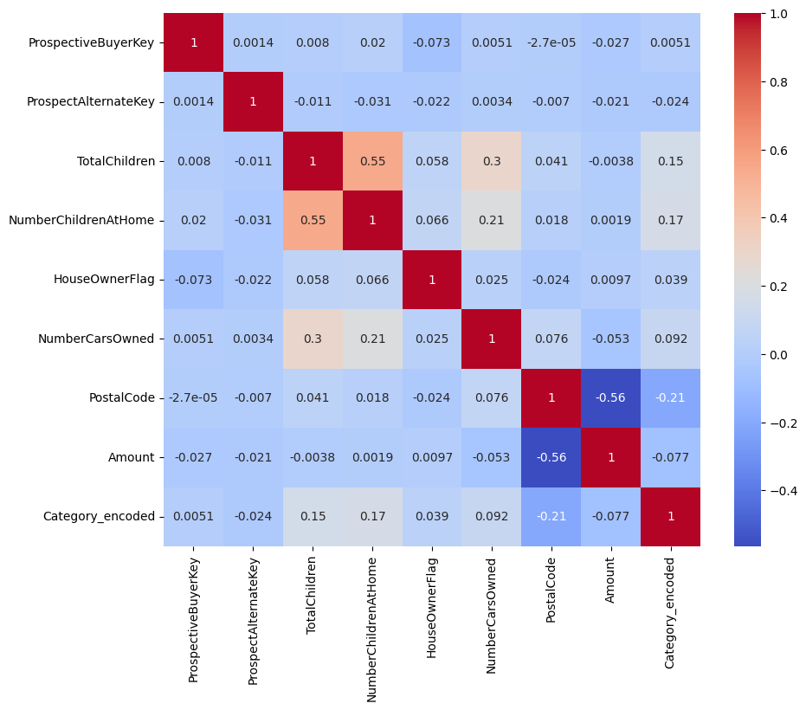
图 3 Correlation heat map

1.3 Machine Learning Process

1.3.1 Data Preparation and Data Processing
The table contains a total of 24 columns, but some data are not helpful for us to predict the type, such as name columns, email address, etc. We also need to process the missing values in the data, and some contradictory data are also regarded as abnormal data to clear up, we also need to transform the format of time, and after data processing, we trained the model to predict the type more accurately
- #缺失值处理
- df.drop(['FirstName', 'LastName'], axis=1, inplace=True)
- df = df[df['TotalChildren'] >= df['NumberChildrenAtHome']]
- df.dropna(subset=['YearlyIncome', 'TotalChildren', 'NumberCarsOwned'], inplace=True)

- #转换时间格式
- df['BirthDate'] = pd.to_datetime(df['BirthDate'])
- df['YearlyIncome'] = df['YearlyIncome'].astype(int)
- df['Age'] = pd.to_datetime('today').year - pd.to_datetime(df['BirthDate']).dt.year

- text_columns = df.select_dtypes(include=['object']).columns
- df[text_columns] = df[text_columns].apply(lambda x: x.str.lower())
- df.head()
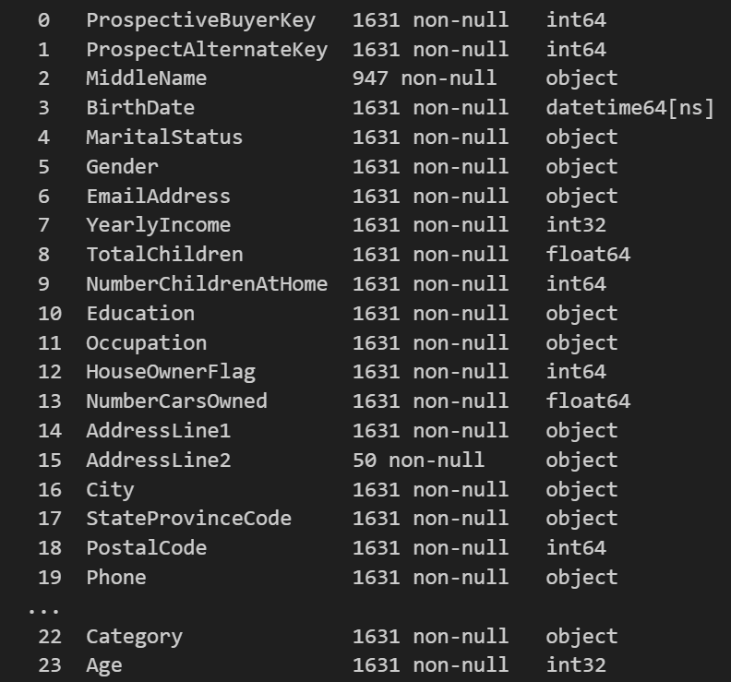
图 4 Cleaned data

1.3.2 Model Selection and Performance Analyze

1.3.2.1 Linear regression
After data processing, the pipeline model is trained by dividing the data set into training set and test set, and the scatter plot and radar plot of the actual data and predicted data are drawn, and the coefficients of the model are displayed
- # Enter your code here for linear regression

- # 处理缺失值
- numeric_features = ['YearlyIncome', 'TotalChildren', 'NumberCarsOwned', 'Age']
- categorical_features = ['MaritalStatus', 'Gender', 'Education', 'Occupation', 'HouseOwnerFlag', 'City']

- # 选择特征和标签
- X = df.drop(['Amount'], axis=1)
- y = df['Amount']

- # 编码分类特征
- numeric_transformer = Pipeline(steps=[('scaler', StandardScaler())])
- categorical_transformer = Pipeline(steps=[
- ('onehot', OneHotEncoder(handle_unknown='ignore'))
- ])
- preprocessor = ColumnTransformer(
- transformers=[
- ('num', numeric_transformer, numeric_features),
- ('cat', categorical_transformer, categorical_features),
- ])

- # 创建整个处理流程
- model = Pipeline(steps=[('preprocessor', preprocessor),
- ('regressor', LinearRegression())])

- # 划分训练集和测试集
- X_train, X_test, y_train, y_test = train_test_split(X, y, test_size=0.2, random_state=42)

- # 训练模型
- model.fit(X_train, y_train)

- # 预测
- y_pred = model.predict(X_test)

- # 评估模型
- mse = mean_squared_error(y_test, y_pred)
- r2 = r2_score(y_test, y_pred)

- # 绘制实际值与预测值的散点图
- plt.figure(figsize=(10, 6))
- plt.scatter(y_test, y_pred, color='blue', alpha=0.5, label='Actual vs Predicted')
- plt.plot([y_test.min(), y_test.max()], [y_test.min(), y_test.max()], 'k--', lw=4, label='Perfect Fit')
- plt.xlabel('Actual Amount')
- plt.ylabel('Predicted Amount')
- plt.title('Actual vs Predicted Bike Amount')
- plt.legend()
- plt.text(0.02, 0.95, f'MSE: {mse:.2f}', transform=plt.gca().transAxes, fontsize=12, color='green')
- plt.text(0.02, 0.90, f'R² Score: {r2:.2f}', transform=plt.gca().transAxes, fontsize=12, color='green')
- plt.show()

- # 创建一个简单的图表，仅用于展示文本
- plt.figure(figsize=(6, 4))

- # 由于我们不绘制任何数据点或线条，所以可以使用plt.text来添加文本
- plt.text(0.5, 0.5, f'Model Performance Metrics:\n'
- f'MSE: {mse:.4f}\n'
- f'R² Score: {r2:.4f}',
- horizontalalignment='center',
- verticalalignment='center',
- fontsize=12,
- transform=plt.gca().transAxes) # 使用transAxes来确保文本相对于图表的大小和位置

- # 由于我们不绘制任何实际的图表元素，所以不需要坐标轴
- plt.axis('off')

- # 显示图表
- plt.show()

- # 从模型中提取系数
- coef = model.named_steps['regressor'].coef_

- # 提取数值特征的系数
- numeric_coef = coef[:len(numeric_features)]

- # 标准化系数绝对值，使它们可以比较
- normalized_coef = np.abs(numeric_coef) / np.linalg.norm(np.abs(numeric_coef))

- # 雷达图的角度
- angles = np.linspace(0, 2 * np.pi, len(numeric_features), endpoint=False).tolist()

- # 绘制雷达图
- plt.figure(figsize=(6, 6), dpi=80)
- ax = plt.subplot(111, polar=True)
- ax.fill(angles, normalized_coef, color='red', alpha=0.25)
- ax.plot(angles, normalized_coef, color='red', marker='o')

- # 设置角度标签
- ax.set_thetagrids(np.degrees(angles), numeric_features)

- # 显示图形
- plt.show()
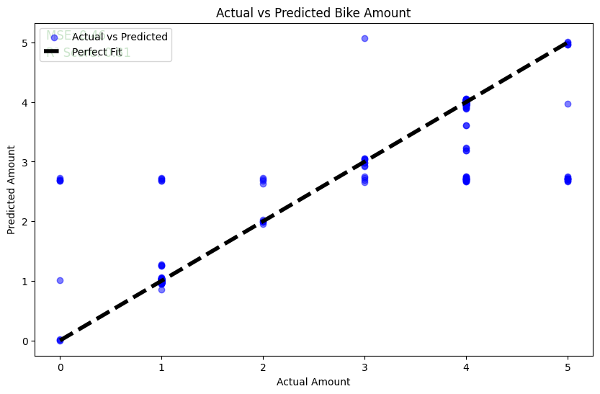
图 5 Linear regression
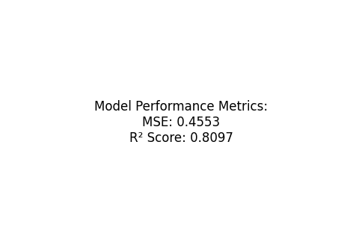
图 6 model performance metrics
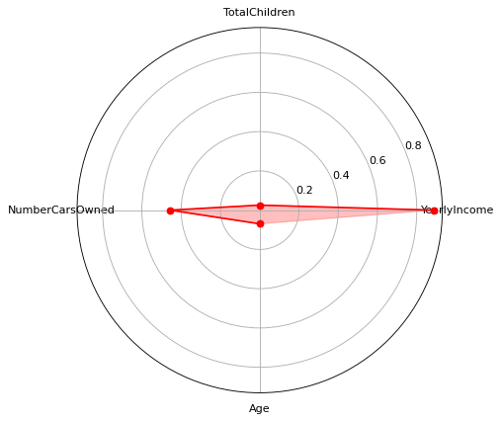
图 7 Radar chart

1.3.2.2 Logistic regression
After data processing, the logistic regression model is trained by dividing the data set into training set and test set, and sigmoid graph is drawn to evaluate the accuracy of the model and output the classification report
- # 特征选择
- X = df[['PostalCode','TotalChildren','NumberChildrenAtHome','Amount','NumberCarsOwned']]
- y = df['Category']

- # 数据划分
- X_train, X_test, y_train, y_test = train_test_split(X, y, test_size=0.2, random_state=42)

- # 模型训练
- log_reg = LogisticRegression(max_iter=1000)
- log_reg.fit(X_train, y_train)

- # 获取模型的系数和截距
- coefficients = log_reg.coef_[0]
- intercept = log_reg.intercept_[0]

- # 定义 sigmoid 函数
- def sigmoid(x):
- return 1 / (1 + np.exp(-x))

- # 选择一个特征（例如 'Amount'）并生成输入数据范围
- amount_range = np.linspace(X['Amount'].min() - 10, X['Amount'].max() + 10, 100)

- # 计算对应的 sigmoid 输出
- y_sigmoid = sigmoid(coefficients[3] * amount_range + intercept)

- # 绘制 sigmoid 曲线
- plt.figure(figsize=(10, 7))
- plt.plot(amount_range, y_sigmoid, label='Sigmoid Function')
- plt.title('Sigmoid Curve')
- plt.xlabel('Input')
- plt.ylabel('Output')
- plt.legend()
- plt.grid(True)
- plt.show()

- # 性能评估
- y_pred = log_reg.predict(X_test)
- print("Accuracy:", accuracy_score(y_test, y_pred))
- print("分类报告:\n", classification_report(y_test, y_pred))
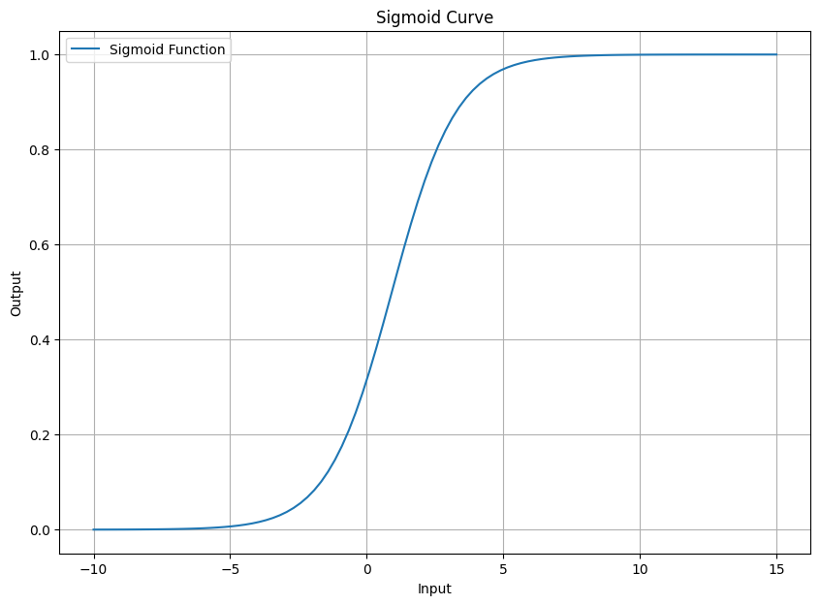
图 8 sigmoid图
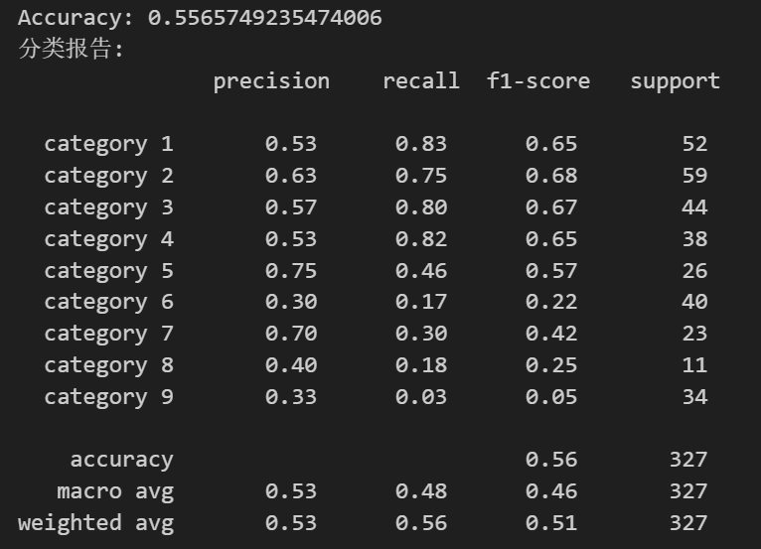
图 9 logistic regression result

1.3.2.3 KNN
After data processing, the KNN model is trained by dividing the data set into training set and test set, and confusion matrix is drawn to evaluate the accuracy of the model and output the classification report
- # X是特征数据，y是目标变量
- X = df[['PostalCode','TotalChildren','NumberChildrenAtHome','Amount','NumberCarsOwned']]
- y = df['Category']

- X_train, X_test, y_train, y_test = train_test_split(X, y, test_size=0.2, random_state=42)
- # 测试集的比例为20%，随机种子为42

- k = 3 # 选择K值
- knn = KNeighborsClassifier(n_neighbors=k)
- # 使用自带的函数进行KNN分类，考虑最近的3个邻居

- knn.fit(X_train, y_train) # 训练模型

- y_pred = knn.predict(X_test)

- # 计算混淆矩阵
- cm = confusion_matrix(y_test, y_pred)

- # 绘制混淆矩阵热图
- plt.figure(figsize=(10, 7))
- sns.heatmap(cm, annot=True, fmt="d", cmap="Blues")
- plt.title('Confusion Matrix')
- plt.xlabel('Predicted Label')
- plt.ylabel('True Label')
- plt.show()

- print("Accuracy:", accuracy_score(y_test, y_pred))
- print("分类报告:\n", classification_report(y_test, y_pred))
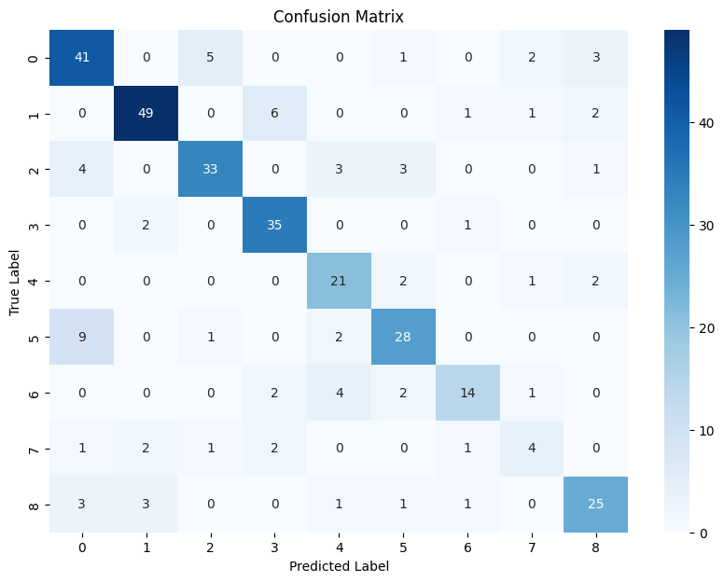
图 10 KNN confusion matrix
Shows the accuracy of the model's predictions for each category, with the diagonal line representing the number of correct predictions
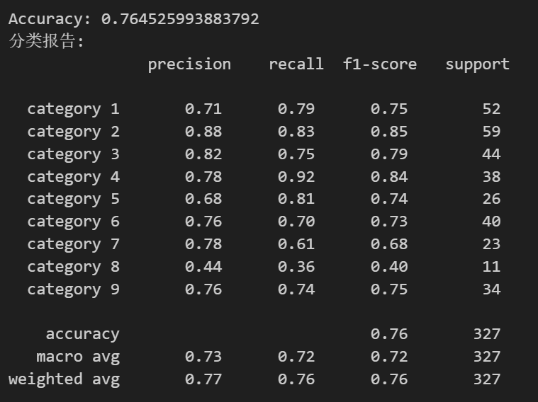
图 11 KNN result
Accuracy : The proportion of samples predicted to be positive that are actually positive
Recall rate : The proportion of samples that are actually positive that are predicted to be positive.
F1 Score : A harmonic average of accuracy and recall, used to balance the importance of the two.

1.3.2.4 Tree-based model
By preprocessing data, selecting features, creating and training decision tree classifiers, and visualizing and outputting classification rules, a complete decision tree classification model is completed
- # Enter your code here for tree-based decision model
- # drop_first=True 意味着会丢弃第一个类别以避免虚拟变量陷阱。
- df = pd.get_dummies(df, columns=['MaritalStatus', 'Gender', 'Education', 'Occupation', 'City'], drop_first=True)

- # 选择了一些特征进行模型训练
- features = ['YearlyIncome', 'TotalChildren', 'HouseOwnerFlag', 'NumberCarsOwned', 'Age'] + \
- list(df.columns[df.columns.str.startswith(('MaritalStatus', 'Gender', 'Education', 'Occupation', 'City'))])

- # 特征集 X，包括所有选择的特征
- X = df[features] # 特征集

- # 目标变量（可以替换为别的分类目标）
- y = df['YearlyIncome']

- X_train, X_test, y_train, y_test = train_test_split(X, y, test_size=0.2, random_state=42)

- # 创建分类器
- model = DecisionTreeClassifier(max_leaf_nodes=9, random_state=42)

- # 训练模型
- model.fit(X_train, y_train)

- # 使用 matplotlib 绘制决策树
- plt.figure(figsize=(20, 10))
- plot_tree(model, feature_names=X.columns, filled=True, rounded=True)
- plt.title('Decision Tree for Bike Buyers Classification')# 添加标题
- plt.show() # 显示图形

- # 步骤 6: 输出分类规则
- # 导出决策树的文本规则
- tree_rules = export_text(model, feature_names=list(X.columns))
- print(tree_rules) # 打印分类规则
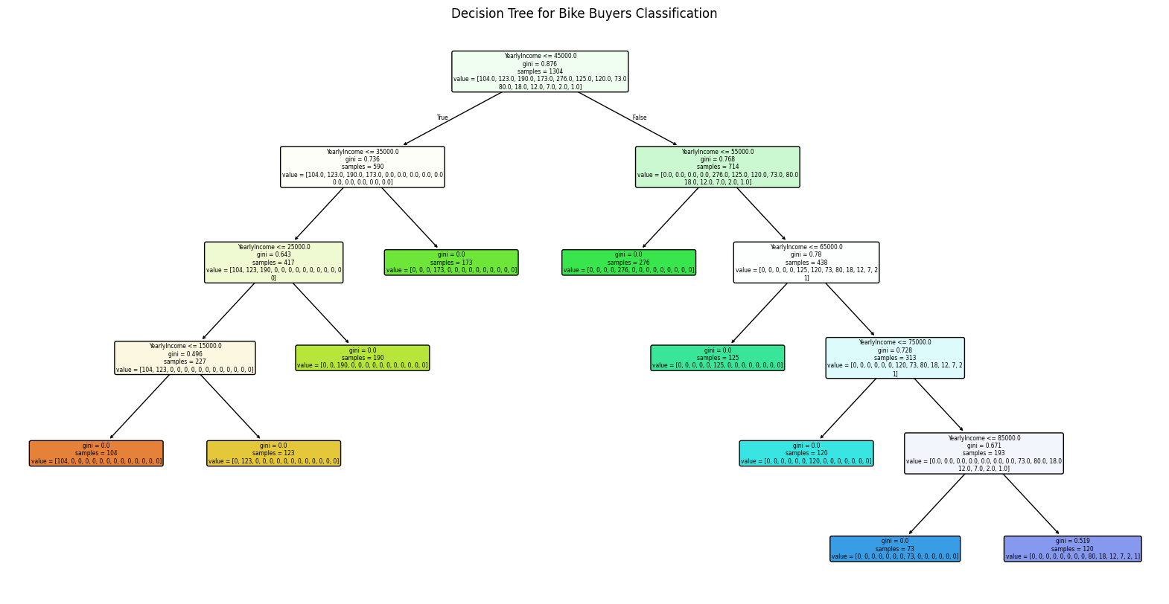
图 12 tree-based model
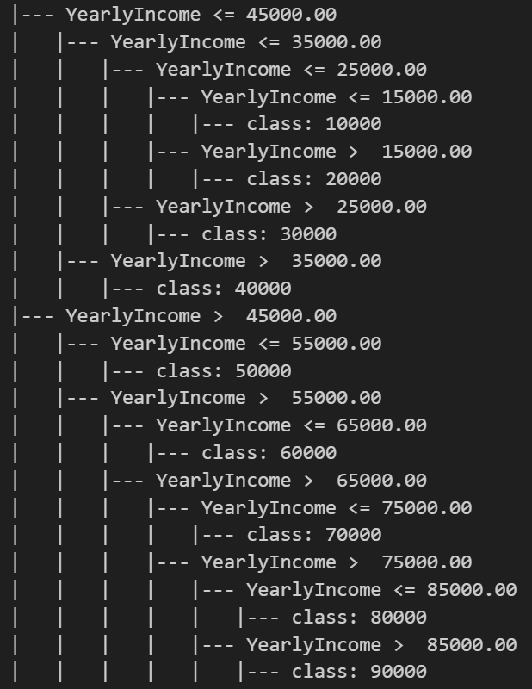
图 13 Decision tree

1.3.2.5 Gradient Boosting Trees
Through data processing, the data set is divided into training set and test set, and the Gradient Boosting model is trained to calculate ROC curve and AUC, and finally the ROC curve is drawn
- # Enter your code here for Gradient Boosting
- # 选择特征和目标变量
- X = df[['PostalCode', 'TotalChildren', 'NumberChildrenAtHome', 'Amount', 'NumberCarsOwned']]
- y = df['Category'] # 目标变量

- # 将目标变量二值化
- y_bin = label_binarize(y, classes=range(len(df['Category'].unique())))

- # 分割数据集为训练集和测试集
- X_train, X_test, y_train, y_test = train_test_split(X, y_bin, test_size=0.2, random_state=42, stratify=y)

- # 创建和训练 Gradient Boosting 模型
- gb_clf = OneVsRestClassifier(GradientBoostingClassifier(n_estimators=100, random_state=42))
- gb_clf.fit(X_train, y_train)

- # 模型预测
- y_pred_bin = gb_clf.predict(X_test)

- # 将二值化的预测结果转换回原始类别标签
- y_test_labels = np.argmax(y_test, axis=1)
- y_pred_labels = np.argmax(y_pred_bin, axis=1)

- # 计算 ROC 曲线和 AUC
- y_prob = gb_clf.predict_proba(X_test)
- fpr = {}
- tpr = {}
- roc_auc = {}

- # 如果是多分类问题，计算每个类别的 ROC 曲线
- for i in range(y_bin.shape[1]):
- fpr[i], tpr[i], _ = roc_curve(y_test[:, i], y_prob[:, i])
- roc_auc[i] = auc(fpr[i], tpr[i])

- # 绘制 ROC 曲线
- plt.figure(figsize=(10, 7))
- for i in range(y_bin.shape[1]):
- plt.plot(fpr[i], tpr[i], label=f'Class {i} (AUC = {roc_auc[i]:.2f})')

- plt.plot([0, 1], [0, 1], 'k--')
- plt.xlim([0.0, 1.0])
- plt.ylim([0.0, 1.05])
- plt.xlabel('False Positive Rate')
- plt.ylabel('True Positive Rate')
- plt.title('Receiver Operating Characteristic (ROC) Curve')
- plt.legend(loc="lower right")
- plt.show()

- # 评估模型
- accuracy = accuracy_score(y_test_labels, y_pred_labels)
- print(f"模型准确率: {accuracy}")
- print("分类报告:\n", classification_report(y_test_labels, y_pred_labels))
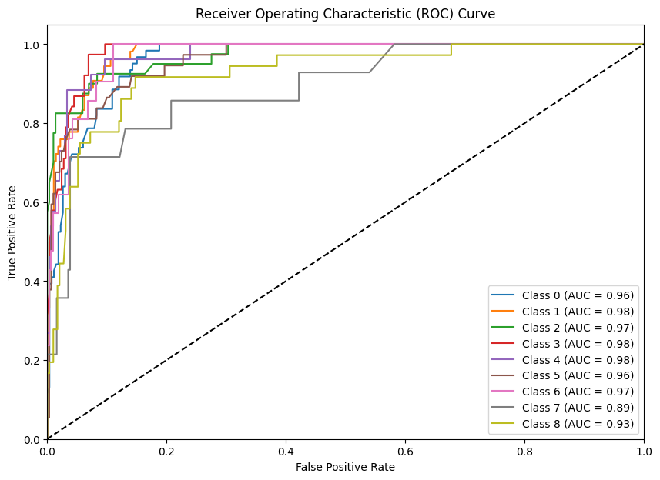
图 14 ROC Curve
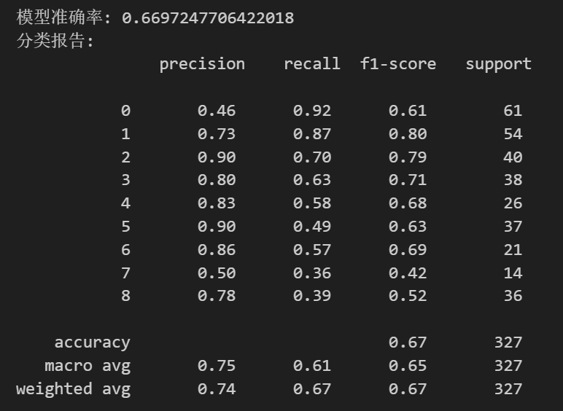
图 15 Gradient Boosting Trees result

1.3.2.6 K-Means
K-means is an unsupervised method used for clustering, so the dataset used for training does not require labels. We set the K values to 3 and 9 respectively, and obtained different clustering results, as shown in Figure 17.
Left chart (k=3):
When k=3, the K-means algorithm divides the data into three clusters. We can observe three distinct clusters in the figure, each identified and labeled by the K-means algorithm with different colors. The red X markers represent the centroid of each cluster.
Right chart (k=9):
When k=9, the K-means algorithm segments the data into nine clusters. Compared to k=3, the clustering is more detailed, with smaller clusters. The figure displays nine clusters in various colors, and the centroid of each cluster is again marked with a red X.

Analysis and Comparison:
In the case of k=3, the clustering results show relatively large clusters, with each cluster having a more concentrated shape.
In contrast, when k=9, the data is segmented into multiple smaller clusters, with each cluster's centroid positioned closer to the average location of its internal data points.
We use silhouette value to evaluate the performance of the model, as shown in Figure 16. silhouette score for k equal to 9 is more closer to 1. It shows taht k =9 has better clustering effect
- # Enter your code here for K-means

- # 创建LabelEncoder实例
- label_encoder = LabelEncoder()

- # 对'Category'列进行标签编码
- df['Category_encoded'] = label_encoder.fit_transform(df['Category'])+1

- X = df[['Amount','Category_encoded']].values

- # 使用k=3进行k-means聚类
- kmeans_3 = KMeans(n_clusters=3, random_state=42)
- labels_3 = kmeans_3.fit_predict(X)

- # 使用k=9进行k-means聚类
- kmeans_9 = KMeans(n_clusters=9, random_state=42)
- labels_9 = kmeans_9.fit_predict(X)

- # 计算轮廓系数
- silhouette_avg_3 = silhouette_score(X, labels_3)
- silhouette_avg_9 = silhouette_score(X, labels_9)

- print(f"Silhouette Score for k=3: {silhouette_avg_3}")
- print(f"Silhouette Score for k=9: {silhouette_avg_9}")

- # 可视化结果
- fig, ax = plt.subplots(1, 2, figsize=(12, 6))

- # k=3的聚类结果
- ax[0].scatter(X[:, 0], X[:, 1], c=labels_3)
- ax[0].set_title('k=3 Clustering')

- # k=9的聚类结果
- ax[1].scatter(X[:, 0], X[:, 1], c=labels_9)
- ax[1].set_title('k=9 Clustering')

- plt.show()
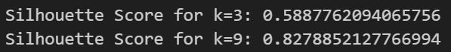
图 16 k-means result
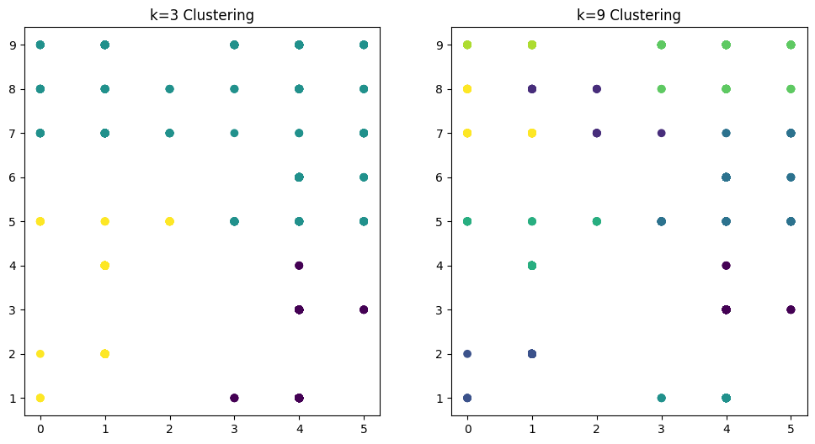
图 17 k-means

1.3.2.7 DBSCAN
DBSCAN：1. Data Preprocessing: Feature Selection and Standardization (Amount and Category)
2. Clustering: Performing Density-Based Clustering with DBSCAN Algorithm
3. Visualization: Visualizing Clustering Results to Aid Understanding of Data Structure and Clustering Patterns
We reclassified data from Excel where different amounts correspond to different categories. We iterate through each label and plot a scatter plot based on the label type. Noise points (labels as -1) are individually marked in black, while different clusters are marked with different colors.
- X = df[['Amount','Category_encoded']].values # 提取需要处理的特征作为numpy数组

- # 如果数据不是同一量级，可以进行标准化处理
- scaler = StandardScaler()vv
- X_scaled = scaler.fit_transform(X)

- eps = 0.3 # 邻域半径
- min_samples = 10 # 最小样本数
- dbscan = DBSCAN(eps=eps, min_samples=min_samples)
- labels = dbscan.fit_predict(X_scaled)

- # 将结果添加到数据框中
- df['Cluster'] = labels

- output_file_path = 'output_data.xlsx'
- df.to_excel(output_file_path, index=False)
- print(f"Cluster labels:\n{labels}")
- print(f"Output saved to {output_file_path}")
- plt.figure(figsize=(10, 6))

- # 提取每个簇的数据
- unique_labels = set(labels)
- colors = plt.cm.get_cmap('tab10', len(unique_labels))

- for i, label in enumerate(unique_labels):
- if label == -1:
- # 如果是噪声点，以黑色单独标记
- plt.scatter(X[labels == label, 0], X[labels == label, 1], color='black', s=30, label='Noise')
- else:
- plt.scatter(X[labels == label, 0], X[labels == label, 1], color=colors(i), s=30, label=f'Cluster {label}')

- plt.title('DBSCAN Clustering')
- plt.xlabel('Amount')
- plt.ylabel('Category')
- plt.legend()
- plt.grid(True)
- plt.show()
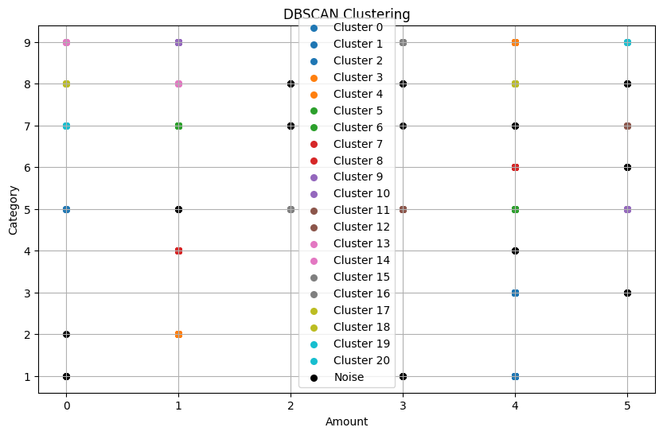
图 18 dbscan

1.3.2.8 Random Forest
Random forest is a bagging algorithm in ensemble learning. This algorithm trains different models on different subsets of the original dataset. When predicting new sample target values, the algorithm selects the majority prediction as the final prediction based on the values predicted by different models.
We create and train a one vs rest random forest models with 100 estimators, and plot the accuracy-recall curves for each category. We also printed the accuracy of the model and a report about various evaluation metrics at the end, as shown in Figure 20.
- label_encoder = LabelEncoder()
- df['Category'] = label_encoder.fit_transform(df['Category'])

- # 分离特征和目标变量
- X = df[['PostalCode','TotalChildren','NumberChildrenAtHome','Amount','NumberCarsOwned']]
- y = df['Category']
- # 将目标变量二值化
- y_bin = label_binarize(y, classes=range(len(df['Category'].unique())))

- # 分割数据集为训练集和测试集
- X_train, X_test, y_train, y_test = train_test_split(X, y_bin, test_size=0.2, random_state=42)

- # 创建和训练一对多的随机森林模型
- ovr_rf_model = OneVsRestClassifier(RandomForestClassifier(n_estimators=100, random_state=42))
- ovr_rf_model.fit(X_train, y_train)

- # 绘制每个类别的精确率-召回率曲线
- plt.figure(figsize=(10, 7))
- for i in range(y_bin.shape[1]):
- PrecisionRecallDisplay.from_estimator(ovr_rf_model.estimators_[i], X_test, y_test[:, i], name=f"Class {i+1}")

- plt.title('Precision-Recall Curve for Multiclass')
- plt.show()

- # 评估模型
- y_pred = ovr_rf_model.predict(X_test)
- print("准确率:", accuracy_score(y_test, y_pred))
- print("分类报告:\n", classification_report(y_test, y_pred))
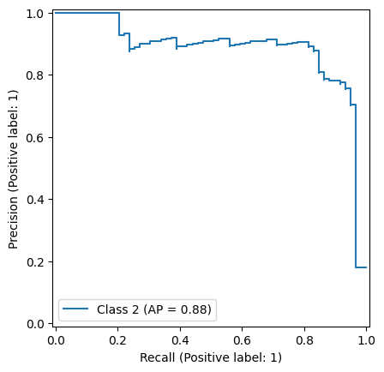
图 19 precision-recall curve
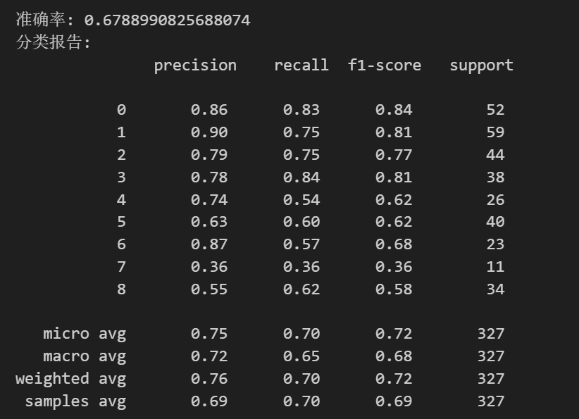
图 20 random forest result

1.3.2.9 AdaBoost
AdaBoost is a gradient boosting algorithm in ensemble learning. Each iteration during model training will reduce the error and continuously improve the accuracy. We set the number of estimators to 100 and selected the 'SAMME' algorithm when initializing the model instance.
After the model is trained, we make predictions on the test set and plot the ROC curves for each category, as shown in Figure 21. Each curve can calculate its AUC value, with the curve closer to the upper left corner having a higher AUC value. We also printed the overall accuracy and report, as shown in Figure 22.
- # 假设 df 已经被定义并包含了所需的数据
- X = df[['PostalCode', 'TotalChildren', 'NumberChildrenAtHome', 'Amount', 'NumberCarsOwned']]
- y = df['Category']

- # 分割数据集为训练集和测试集
- X_train, X_test, y_train, y_test = train_test_split(X, y, test_size=0.2, random_state=42)

- # 初始化 AdaBoost 分类器
- ada = AdaBoostClassifier(n_estimators=100, algorithm='SAMME', random_state=42)

- # 拟合模型
- ada.fit(X_train, y_train)

- # 预测测试集
- y_pred = ada.predict(X_test)

- # 评估模型
- accuracy = accuracy_score(y_test, y_pred)

- # 打印准确率和分类报告
- print(f'Accuracy: {accuracy}')
- print("分类报告:\n", classification_report(y_test, y_pred))
- # 计算并绘制每个类别的ROC曲线
- n_classes = len(np.unique(y_test))
- if n_classes == 1:
- print("Warning: Only one class in the test set. ROC curve will not be meaningful.")
- else:
- plt.figure(figsize=(10, 7))
- colors = ['b', 'g', 'r', 'c', 'm', 'y', 'k'] # 可以根据需要调整颜色列表
- for i, cls in enumerate(np.unique(y_test)):
- y_test_binary = (y_test == cls).astype(int)
- y_scores = ada.predict_proba(X_test)[:, i]
- fpr, tpr, _ = roc_curve(y_test_binary, y_scores)
- roc_auc = auc(fpr, tpr)
- plt.plot(fpr, tpr, color=colors[i % len(colors)], label=f'Class {cls} (AUC = {roc_auc:.2f})')

- plt.legend(loc="lower right")
- plt.plot([0, 1], [0, 1], 'k--') # 绘制对角线（随机猜测线）
- plt.xlim([0.0, 1.0])
- plt.ylim([0.0, 1.05])
- plt.xlabel('False Positive Rate')
- plt.ylabel('True Positive Rate')
- plt.title('ROC Curve for All Classes')
- plt.show()
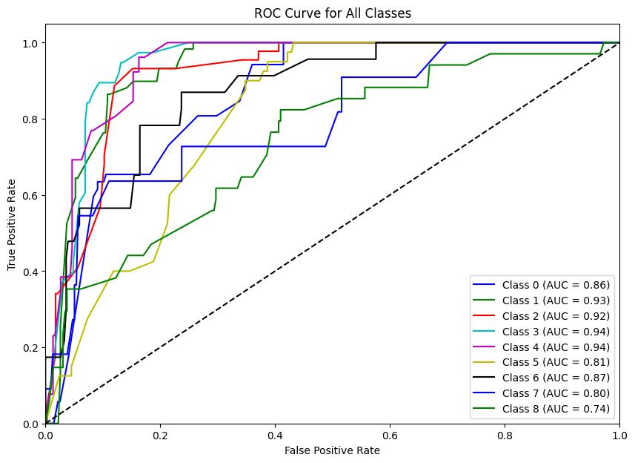
图 21 adaboost roc curve
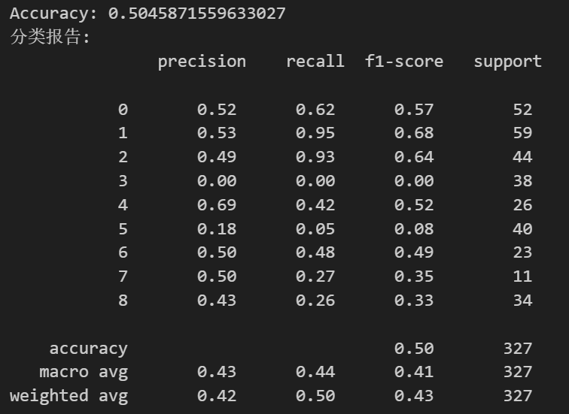
图 22 adaboost result

1.3.2.10 PCA
We selected five main colums: postal code, total children, number of children at home, amount, and number of cars owned. A StandardScaler object scaler is created and used to standardize the data in data_for_pca, ensuring that each feature has a mean of 0 and a variance of 1. An instance of PCA is created. The fit method is called with scaled_data to fit the PCA model using the standardized data, allowing PCA to compute the principal components. This line prints the explained variance ratio of each principal component. This helps in understanding how much variance in the data is explained by each principal component. So , we can see the importance of these five columns: postal code> total children>number of children at home> amount> number of cars owned.
- cleaned_data = df.dropna()
- # 选择用于PCA的数据列，通常是数值型数据列
- selected_columns = ['PostalCode','TotalChildren','NumberChildrenAtHome','Amount','NumberCarsOwned']
- data_for_pca = cleaned_data[selected_columns]

- # 标准化数据
- scaler = StandardScaler()
- scaled_data = scaler.fit_transform(data_for_pca)
- # 创建PCA对象
- pca = PCA()

- # 在标准化后的数据上拟合PCA模型
- pca.fit(scaled_data)

- # 查看主成分的方差解释比例
- print(pca.explained_variance_ratio_)

- # 可选择性地，将数据转换到PCA的主成分空间
- pca_data = pca.transform(scaled_data)
- # 将PCA转换后的数据转为DataFrame
- pca_df = pd.DataFrame(data=pca_data, columns=['PostalCode','TotalChildren','NumberChildrenAtHome','Amount','NumberCarsOwned']) # 根据实际主成分数目命名列名

- # 将PCA转换后的数据与原始数据合并（如果需要）
- final_data = pd.concat([cleaned_data.reset_index(drop=True), pca_df], axis=1)

- # 可选择性的输出结果或进一步处理
- print(final_data.head())
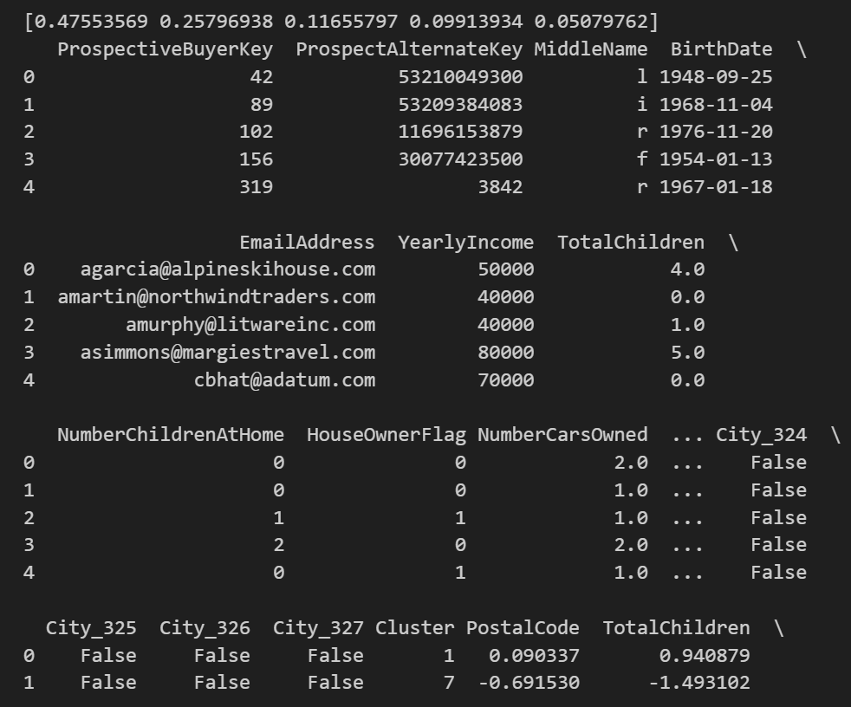
图 23 adaboost result

1.3.3 Model Evaluation and Performance Analysis
We first use cross validation to evaluate the performance of logistic regression and KNN, and then evaluate the performance of KNN using different folds. The evaluation metric is accuracy. According to Figure 24, we can conclude that knn performs better than logistic regression. And different folds (k) correspond to different accuracies
For unsupervised learning K-means, we plot the elbow curve as shown in Figure 25 and consider 3 to be the most suitable cluster number.
- # Add your code here for comparing your models. Describe in the markdown below why the model you chose is the best model.

- X = df[['PostalCode','TotalChildren','NumberChildrenAtHome','Amount','NumberCarsOwned']]
- y = df['Category']

- logistic_reg = LogisticRegression(max_iter=1000)
- knn = KNeighborsClassifier(n_neighbors=3)

- # 交叉验证比较模型性能
- logistic_scores = cross_val_score(logistic_reg, X, y, cv=4, scoring='accuracy')
- knn_scores = cross_val_score(knn, X, y, cv=4, scoring='accuracy')

- # 输出每个模型的交叉验证准确率
- print("Logistic Regression Accuracy:", logistic_scores.mean())
- print("knn Accuracy:", knn_scores.mean())

- #进行k不同交叉验证
- knn_scores_cv4 = cross_val_score(knn, X, y, cv=4, scoring='accuracy')
- knn_scores_cv10 = cross_val_score(knn, X, y, cv=10, scoring='accuracy')

- # 输出k为不同值的交叉验证准确率
- print("knn with cv=4 Accuracy:", knn_scores_cv4.mean())
- print("knn with cv=10 Accuracy:", knn_scores_cv10.mean())
- #绘制肘部曲线以找到最好的k值
- elbow = []

- for i in range(1, 20): # 创建遍历，找到最合适的k值
- kmeans = KMeans(n_clusters=i, init='k-means++', random_state=100)
- kmeans.fit(X)
- elbow.append(kmeans.inertia_)

- plt.figure(figsize=(9, 6))
- plt.plot(range(1, 20), elbow, marker='o', linestyle='--')
- plt.xlabel('Number of Clusters (K)')
- plt.ylabel('Inertia')
- plt.title('Elbow Method for Optimal K')
- plt.xticks(np.arange(1, 20, 1))
- plt.grid(True)
- plt.show()
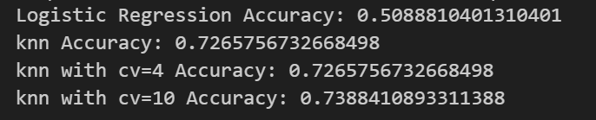
图 24 logistic regression and KNN
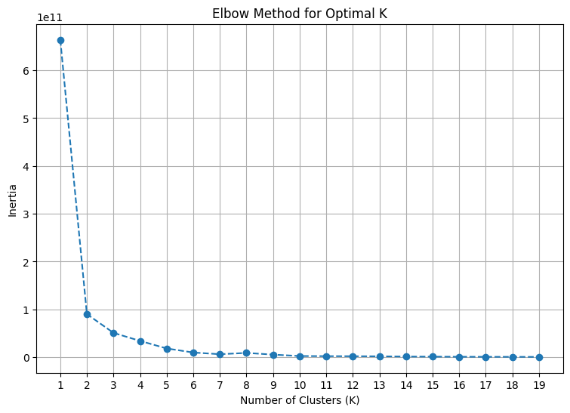
图 25 K-means Elbow curve
In order to select the most appropriate classification model, we conducted cross validation on five different algorithms, and the results are shown in Figure 26.
- models = {
- "Logistic Regression": log_reg,
- "Random Forest": ovr_rf_model,
- "KNN": knn,
- "AdaBoost": ada,
- "Gradient Boosting": gb_clf
- }

- # 评估模型
- for name, model in models.items():
- scores = cross_val_score(model, X, y, cv=5, scoring='accuracy')
- print(f"{name} Accuracy: {np.mean(scores):.2f} (+/- {np.std(scores):.2f})")
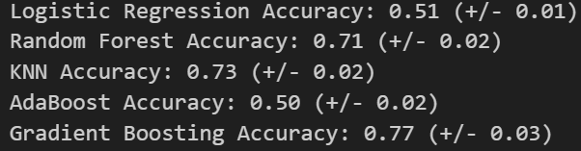
图 26 Model comparison

1.3.4 Model Improvement or Optimization
To improve the performance of the model, we convert the ‘BirthDate’ into a date value and calculate the’Age’ feature based on the ‘Birthdate’ . For missing values of numerical features, we use the median to fill in. For categorical features, we use majority of values to fill in. And we convert ‘Gender’ and ‘MaritalStatus’ into numerical values of 0 and 1. For other categorical features, we use ‘OneHotEncoder’ .
We train the model based on the processed dataset. The obtained performance is shown in Figures 27 and 28. It can be seen that the MSE value has decreased and the R-squared value has greatly improved, closing to 1.
Due to the encoding of various classification features, we can obtain more information from the sample. The model can automatically select useful features to achieve higher performance.
- # 处理BirthDate为年龄
- df['BirthDate'] = pd.to_datetime(df['BirthDate'])
- df['Age'] = (pd.to_datetime('today') - df['BirthDate']).dt.days / 365.25

- # 处理缺失值（这里假设用中位数和众数填充，具体根据你的数据集调整）
- numeric_features = ['YearlyIncome', 'TotalChildren', 'NumberChildrenAtHome', 'NumberCarsOwned', 'PostalCode']
- categorical_features = ['MaritalStatus', 'Gender', 'Education', 'Occupation', 'HouseOwnerFlag', 'City', 'StateProvinceCode']

- for feature in numeric_features:
- df[feature].fillna(df[feature].median(), inplace=True)

- for feature in categorical_features:
- df[feature].fillna(df[feature].mode()[0], inplace=True)

- # 处理Gender和MaritalStatus
- gender_mapping = {'M': 0, 'F': 1}
- df['Gender'] = df['Gender'].map(gender_mapping)

- marital_status_mapping = {'M': 0, 'S': 1} # 根据实际数据调整映射
- df['MaritalStatus'] = df['MaritalStatus'].map(marital_status_mapping)

- # 使用LabelEncoder处理其他分类特征
- label_encoders = {}
- for feature in ['Education', 'Occupation', 'HouseOwnerFlag', 'City', 'StateProvinceCode']:
- label_encoders[feature] = LabelEncoder()
- df[feature] = label_encoders[feature].fit_transform(df[feature])

- # 选择特征和标签
- X = df.drop(['Amount'], axis=1)
- y = df['Amount']

- # 编码分类特征
- numeric_transformer = Pipeline(steps=[('scaler', StandardScaler())])
- categorical_transformer = Pipeline(steps=[
- ('onehot', OneHotEncoder(handle_unknown='ignore'))
- ])
- preprocessor = ColumnTransformer(
- transformers=[
- ('num', numeric_transformer, numeric_features),
- ('cat', categorical_transformer, categorical_features),
- ])

- # 创建整个处理流程
- model = Pipeline(steps=[('preprocessor', preprocessor),
- ('regressor', LinearRegression())])

- # 划分训练集和测试集
- X_train, X_test, y_train, y_test = train_test_split(X, y, test_size=0.2, random_state=42)

- # 训练模型
- model.fit(X_train, y_train)

- # 预测
- y_pred = model.predict(X_test)

- # 评估模型
- mse = mean_squared_error(y_test, y_pred)
- r2 = r2_score(y_test, y_pred)

- # 绘制实际值与预测值的散点图
- plt.figure(figsize=(10, 6))
- plt.scatter(y_test, y_pred, color='blue', alpha=0.5, label='Actual vs Predicted')
- plt.plot([y_test.min(), y_test.max()], [y_test.min(), y_test.max()], 'k--', lw=4, label='Perfect Fit')
- plt.xlabel('Actual Amount')
- plt.ylabel('Predicted Amount')
- plt.title('Actual vs Predicted Bike Amount')
- plt.legend()
- plt.text(0.02, 0.95, f'MSE: {mse:.2f}', transform=plt.gca().transAxes, fontsize=12, color='green')
- plt.text(0.02, 0.90, f'R² Score: {r2:.2f}', transform=plt.gca().transAxes, fontsize=12, color='green')
- plt.show()

- # 创建一个简单的图表，仅用于展示文本
- plt.figure(figsize=(6, 4))

- # 由于我们不绘制任何数据点或线条，所以可以使用plt.text来添加文本
- plt.text(0.5, 0.5, f'Model Performance Metrics:\n'
- f'MSE: {mse:.4f}\n'
- f'R² Score: {r2:.4f}',
- horizontalalignment='center',
- verticalalignment='center',
- fontsize=12,
- transform=plt.gca().transAxes) # 使用transAxes来确保文本相对于图表的大小和位置

- # 由于我们不绘制任何实际的图表元素，所以不需要坐标轴
- plt.axis('off')
- # 显示图表
- plt.show()
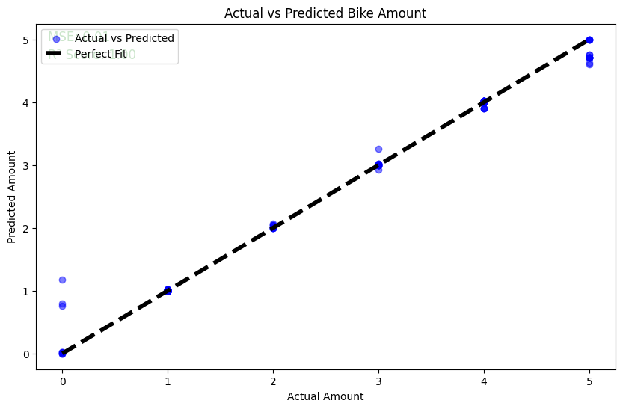
图 27 liner regression
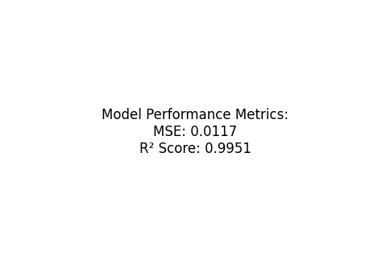
图 28 model performance metrics

2. Practice on Zombie enterprise Dataset

2.1 Business Understanding
By aggregating and cleaning the data from four Excel files, we extracted six feature variables and one target variable for analysis. Our goal is to determine whether a company is a zombie enterprise or not, where a flag value of 0 indicates it is a zombie enterprise, and a flag value of 1 indicates it is not. To achieve this, we plotted different types of charts comparing the various data and selected the two models with the highest accuracy.

2.2 Data Understanding and Exploratory Data Analysis
Judging whether the enterprise is a zombie enterprise through the given data, comparing the accuracy of different forecasting models, and choosing the best model.

2.2.1 Description of Dataset
The data set gives a number of data, such as the registered capital, the shareholding ratio of the controller, the debt financing cost, etc., but there are many missing data, so the missing data should be processed first when analyzing the data, and some data are 0, so the corresponding data should be filled in when analyzing the data.

Exploratory Data Analysis
According to the data obtained from the heat map, select the data items that have a great influence on the categort, and after data cleaning, draw charts such as median, mean and standard deviation for analysis.
- # 计算均值
- mean_values = df[['注册资本', '控制人持股比例','债权融资额度', '债权融资成本', '股权融资额度', '股权融资成本', '内部融资和贸易融资额度', '内部融资和贸易融资成本', '纳税总额', '所有者权益合计']].applymap(lambda x: np.nan if x == 0 else x).mean()

- # 计算中位数
- median_values = df[['注册资本', '控制人持股比例','债权融资额度', '债权融资成本', '股权融资额度', '股权融资成本', '内部融资和贸易融资额度', '内部融资和贸易融资成本', '纳税总额', '所有者权益合计']].applymap(lambda x: np.nan if x == 0 else x).median()

- # 计算标准差
- std_deviation = df[['注册资本', '控制人持股比例', '债权融资额度', '债权融资成本', '股权融资额度', '股权融资成本', '内部融资和贸易融资额度', '内部融资和贸易融资成本', '纳税总额', '所有者权益合计']].applymap(lambda x: np.nan if x == 0 else x).std()

- # 设置matplotlib的字体
- plt.rcParams['font.sans-serif'] = ['SimHei'] # 'SimHei' 是一个常见的支持中文的字体
- plt.rcParams['axes.unicode_minus'] = False # 正确显示负号

- # 数据准备
- columns = ['注册资本', '控制人持股比例', '债权融资额度', '债权融资成本', '股权融资额度', '股权融资成本', '内部融资和贸易融资额度', '内部融资和贸易融资成本', '纳税总额', '所有者权益合计']
- stats_data = pd.DataFrame({
- '均值': mean_values,
- '中位数': median_values,
- '标准差': std_deviation
- })

- # 绘制均值图表
- plt.figure(figsize=(10, 8))
- sns.barplot(x=stats_data['均值'], y=columns)
- plt.title('各特征均值')
- plt.xlabel('均值')
- plt.ylabel('特征')
- plt.show()

- # 绘制中位数图表
- plt.figure(figsize=(10, 8))
- sns.barplot(x=stats_data['中位数'], y=columns)
- plt.title('各特征中位数')
- plt.xlabel('中位数')
- plt.ylabel('特征')
- plt.show()

- # 绘制标准差图表
- plt.figure(figsize=(10, 8))
- sns.barplot(x=stats_data['标准差'], y=columns)
- plt.title('各特征标准差')
- plt.xlabel('标准差')
- plt.ylabel('特征')
- plt.show()
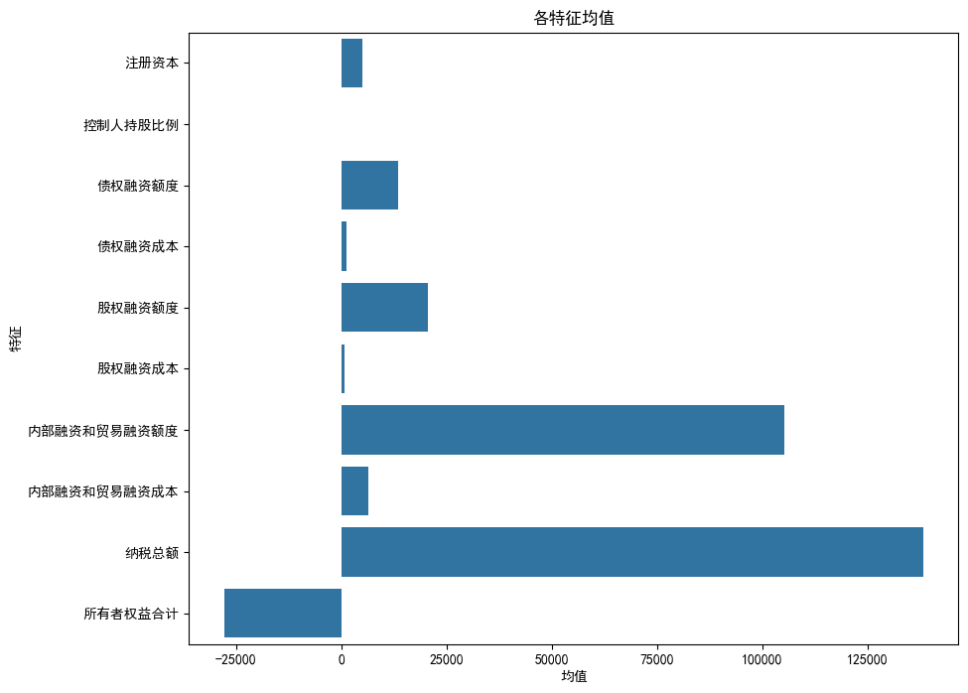
图 29 Mean value
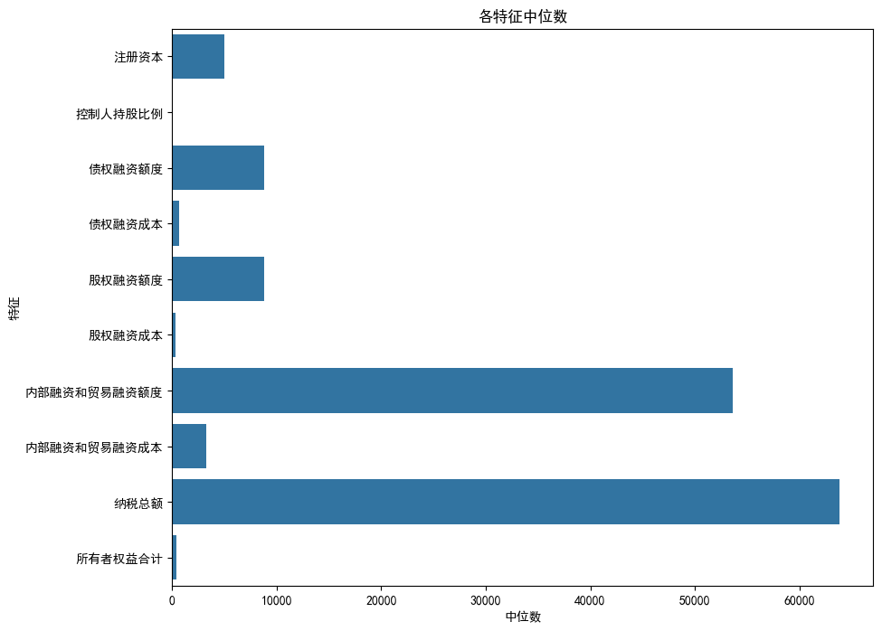
图 30 median
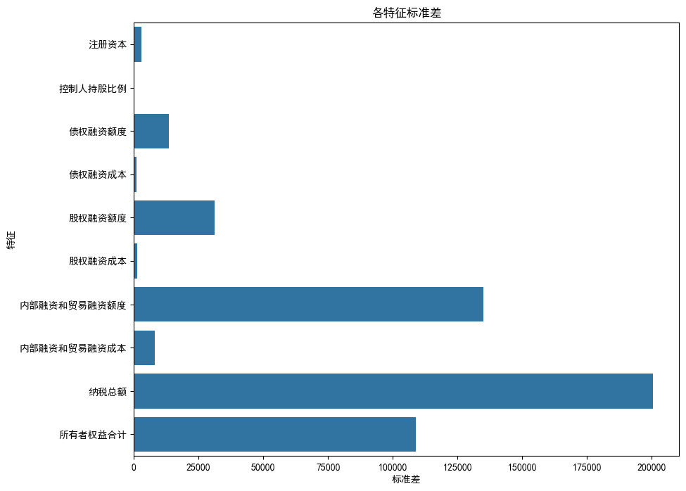
图 31 Standard deviation

Feature Engineering
Calculate the Spearman correlation coefficient of numerical data, and show the correlation coefficient matrix in the form of heat map.
- # 设置matplotlib支持中文显示
- plt.rcParams['font.sans-serif'] = ['SimHei'] # 设置中文显示字体
- plt.rcParams['axes.unicode_minus'] = False # 正确显示负号

- numeric_data = df.select_dtypes(include=['int64', 'float64'])

- # 计算Spearman相关系数
- spearman_corr = numeric_data.corr(method='spearman')
- print(spearman_corr)

- # 绘制热图
- plt.figure(figsize=(20, 12)) # 可以调整图形的大小以更好地展示数据
- sns.heatmap(spearman_corr, annot=True, cmap='coolwarm')

- # 显示热图
- plt.show()
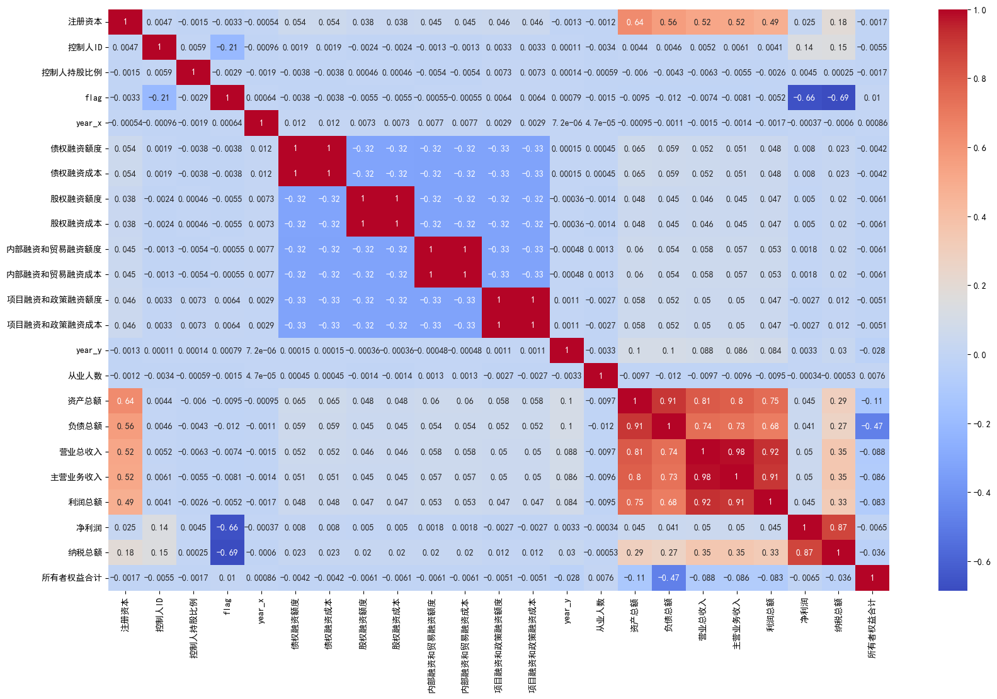
图 32 Correlation heat map

2.3 Machine Learning Process

Data Preparation and Data Processing
Delete missing values, convert data types, process text data, filter data, etc. to ensure data quality and prepare for subsequent data analysis or modeling. Includes deleting all rows with missing values in data set df, converting the data in the specified column into numerical type, filtering the rows with' total business income' greater than or equal to' main business income', converting the' registration time' column into date-time type, and setting it as NaT if it cannot be converted.
- df.dropna(inplace=True)
- numeric_columns = ['从业人数', '资产总额', '负债总额', '营业总收入', '主营业务收入', '利润总额', '净利润', '纳税总额', '所有者权益合计']
- for col in numeric_columns:
- df[col] = pd.to_numeric(df[col], errors='coerce') # 将无法转换的设置为NaN
- df.dropna(inplace=True)
- dfyear = df[df['从业人数'] >= 0]
- dfyear = dfyear [dfyear ['营业总收入'] >= dfyear ['主营业务收入']]

- df['注册时间'] = pd.to_datetime(df['注册时间'], errors='coerce') # errors='coerce' 会将无法转换的日期设置为NaT
- df['注册资本'] = df['注册资本'].astype(float)
- text_columns = df.select_dtypes(include=['object']).columns
- df[text_columns] = df[text_columns].apply(lambda x: x.str.lower() if pd.api.types.is_string_dtype(x) else x)
- exclude_columns = ['ID', '控制人ID']
- df[text_columns.difference(exclude_columns)] = df[text_columns.difference(exclude_columns)].apply(lambda x: x.str.lower())
- df.dropna(subset=['注册资本', '控制人持股比例','注册资本','行业','区域','企业类型','控制人类型','控制人ID','控制人持股比例','flag'], inplace=True)

- df['ID'] = df['ID'].astype(int)
- df[['专利', '商标', '著作权']] =df[['专利', '商标', '著作权']].astype(int)
- dfyear.dropna(inplace=True)

- df.dropna(inplace=True)
- df[['债权融资额度', '债权融资成本', '股权融资额度', '股权融资成本',
- '内部融资和贸易融资额度', '内部融资和贸易融资成本',
- '项目融资和政策融资额度', '项目融资和政策融资成本']] = df[
- ['债权融资额度', '债权融资成本', '股权融资额度', '股权融资成本',
- '内部融资和贸易融资额度', '内部融资和贸易融资成本',
- '项目融资和政策融资额度', '项目融资和政策融资成本']].astype(float)
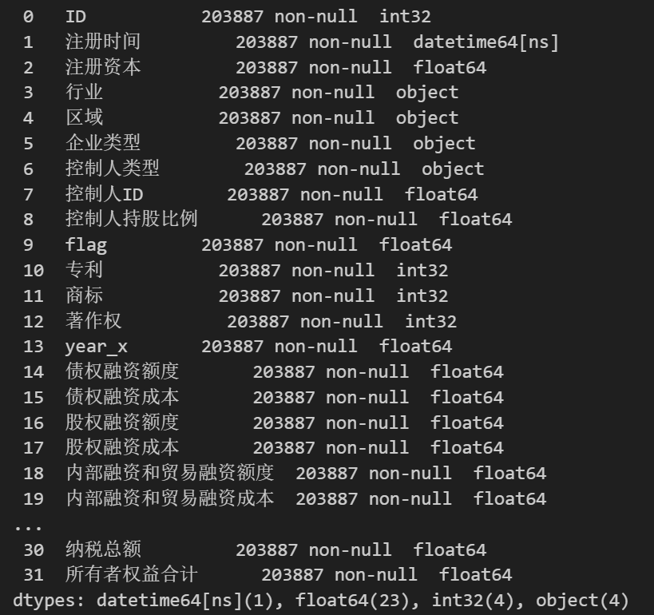
图 33 Cleaned data

Model Selection and Performance Analyze
According to the thermodynamic diagram,we choose the columns which have strong relations to build various models, such as KNN, logistic regression, LDA, random forest and Adaboost. Through different models, the logistic regression has the highest accuracy about predicting whether the entrepreneur can be called ‘Zombie enterprise’.

2.3.2.1 KNN
- # 创建KNN模型实例

- knn = KNeighborsClassifier(n_neighbors=10)

- # 训练模型
- knn.fit(X_train, y_train)

- # 对测试集进行预测
- y_pred = knn.predict(X_test)

- # 计算混淆矩阵
- conf_matrix = confusion_matrix(y_test, y_pred)

- # 计算准确率
- accuracy = accuracy_score(y_test, y_pred)

- # 绘制热图
- plt.figure(figsize=(10, 7))
- sns.heatmap(conf_matrix, annot=True, cmap="Blues")
- plt.xlabel('Predicted')
- plt.ylabel('True')
- plt.show()
- print(f"准确率: {accuracy}")
- print("分类报告:\n", classification_report(y_test, y_pred))
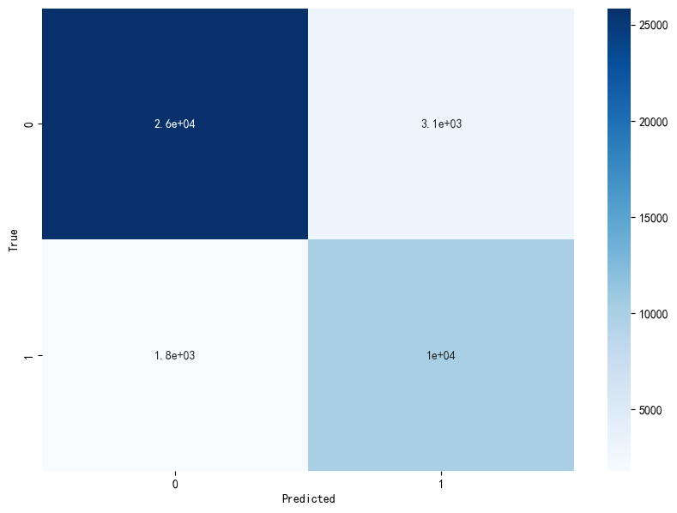
图 34 confusion matrix
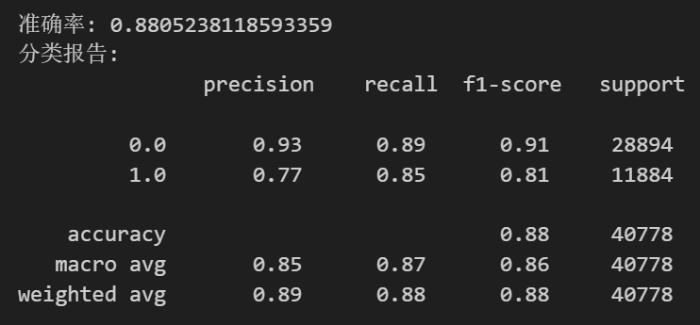
图 35 knn result

2.3.2.2 Logistic Regression
- # 创建sigmoid函数
- def sigmoid(z):
- return 1 / (1 + np.exp(-z))

- # 创建逻辑回归模型实例
- log_reg = LogisticRegression()

- # 训练模型
- log_reg.fit(X_train, y_train)

- # 对测试集进行预测
- y_pred = log_reg.predict(X_test)

- # 打印模型的系数和截距
- print("Intercept:", log_reg.intercept_)
- print("Coefficients:", log_reg.coef_)

- # 绘制所有特征的sigmoid曲线
- for i in range(X.shape[1]):
- x_values = np.linspace(X.iloc[:, i].min() - 50, X.iloc[:, i].max() + 50, 100)
- z = log_reg.intercept_ + log_reg.coef_[0][i] * x_values
- sigmoid_values = sigmoid(z)

- plt.plot(x_values, sigmoid_values)
- plt.title(f'Sigmoid Function for Feature {i+1}')
- plt.xlabel(f'Feature {i+1}')
- plt.ylabel('sigmoid(z)')
- plt.grid(True)
- plt.show()

- print("Accuracy:", accuracy_score(y_test, y_pred))
- print("分类报告:\n", classification_report(y_test, y_pred))
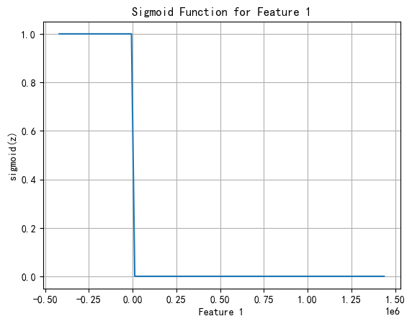
图 36 logistic regression sigmoid curve

2.3.2.3 LDA
- #创建LDA实例并生成数据
- lda = 线性判别分析()
- lda.拟合（X_train，y_train）

- # 对训练集和测试集进行变换
- X_train_lda = lda.变换（X_train）
- X_test_lda = lda.变换（X_test）

- # 预测测试集
- y_pred = lda.预测（X_test）

- # 打印准确率和分类报告
- 打印（“准确度：”，准确度分数（y_test，y_pred））
- print ( "分类报告:\n" ,classification_report(y_test, y_pred))

- # 这里我们仅展示真正标签为0和1的预测分配
- 类别 = [ '真 0' , '真 1' ]
- Predicted_ 0 = [cm[ 0 , 0 ], cm[ 1 , 0 ]] # 预测为0的，其中真正标签是0和1的
- Predicted_1 = [cm[ 0 , 1 ], cm[ 1 , 1 ]] # 预测为1的，其中真正标签是0和1的

- plt.figure(figsize=( 10 , 7 ))
- 索引 = np.arange（len（类别））
- 条形宽度 = 0 . 35

- # 虚拟机版本
- p1 = plt.bar（索引，predicted_0 ， bar_width，标签= '预测0'，颜色= '蓝色'）
- p2 = plt.bar（索引，predicted_1，bar_width，bottom=predicted_ 0，标签= '预测1'，颜色= '橙色​​'）

- plt.xlabel( ‘真实标签’ )
- plt.ylabel( '计数' )
- plt.xticks(索引，类别)
- plt.title( '混淆矩阵的简化表示' )
- plt. 图例()

- plt.显示()

- # 打印准确率和分类报告
- 打印（“准确度：”，准确度分数（y_test，y_pred））
- print ( "分类报告:\n" ,classification_report(y_test, y_pred))
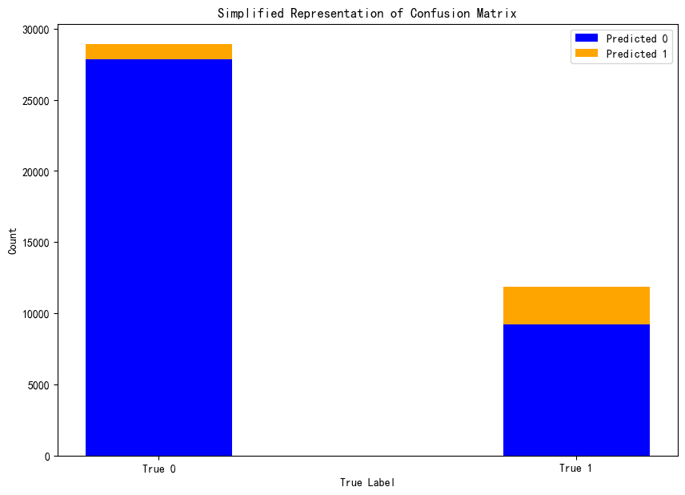
图 37 confusion matrix
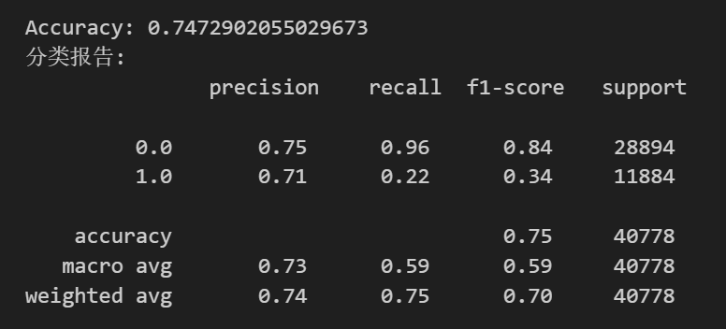
图 38 LDA result

2.3.2.4 Random Forest
- # 标签编码
- label_encoder = LabelEncoder()
- df['flag'] = label_encoder.fit_transform(df['flag'])

- # 创建随机森林模型
- rf_model = RandomForestClassifier(n_estimators=100, random_state=42)

- # 训练模型
- rf_model.fit(X_train, y_train)

- # 预测测试集
- y_pred = rf_model.predict(X_test)
- y_scores = rf_model.predict_proba(X_test)[:, 1] # 获取预测概率

- # 评估模型

- print("Accuracy:", accuracy_score(y_test, y_pred))
- print("分类报告:\n", classification_report(y_test, y_pred))

- # 计算精准率-召回率曲线
- precision, recall, _ = precision_recall_curve(y_test, y_scores)

- # 绘制精准率-召回率曲线
- plt.figure(figsize=(10, 7))
- plt.plot(recall, precision, marker='.')
- plt.title('Precision-Recall Curve')
- plt.xlabel('Recall')
- plt.ylabel('Precision')
- plt.grid(True)
- plt.show()
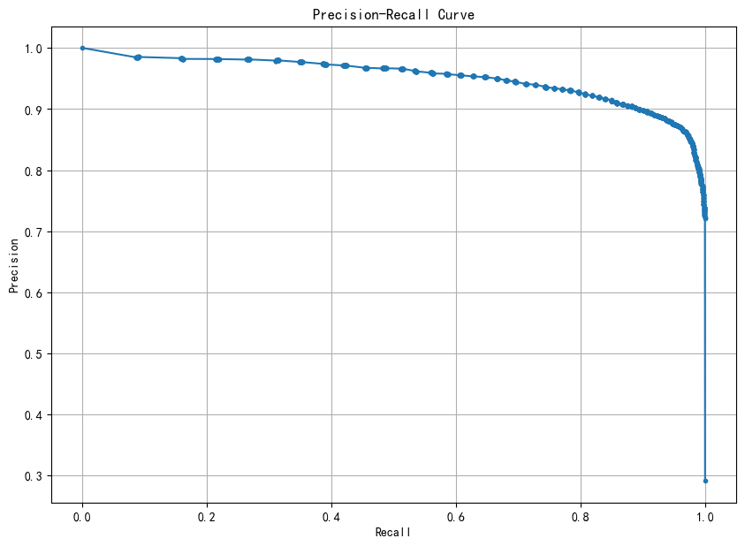
图 39 precision-recall curve
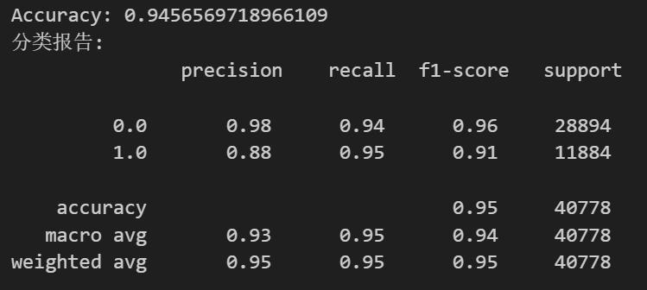
图 40 random forest result

- # 提取特征重要性
- importances = rf_model.feature_importances_
- feature_names = X_test.columns # 假设X_train是一个DataFrame，其列名是特征名

- # 对特征重要性进行排序
- indices = np.argsort(importances)[::-1]

- # 绘制“雷达图”样式的特征重要性图
- plt.figure(figsize=(10, 7))
- angles = np.linspace(0, 2 * np.pi, len(indices), endpoint=False).tolist()

- # 为了使雷达图闭合，我们需要复制第一个特征的重要性
- values = np.concatenate((importances[indices], [importances[indices[0]]]))
- angles += angles[:1]

- # 绘制极坐标图
- ax = plt.subplot(111, polar=True)
- ax.plot(angles, values, color='red', linewidth=2, linestyle='solid')
- ax.fill(angles, values, color='red', alpha=0.25)

- # 设置角度标签
- ax.set_thetagrids(np.degrees(angles[:-1]), feature_names[indices])

- plt.show()
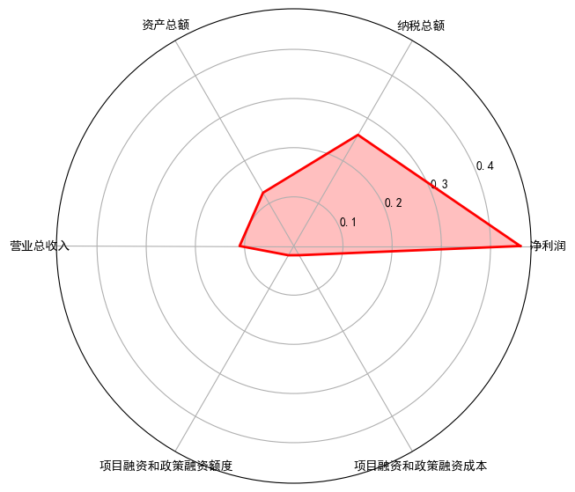
图 41 Radar chart

2.3.2.5 Adaboost
- ada = AdaBoostClassifier(n_estimators=100, algorithm='SAMME', random_state=42)

- # 拟合模型
- ada.fit(X_train, y_train)

- # 预测测试集
- y_pred = ada.predict(X_test)

- # 评估模型
- accuracy = accuracy_score(y_test, y_pred)

- # 打印准确率和分类报告
- print(f'Accuracy: {accuracy}')
- print("分类报告:\n", classification_report(y_test, y_pred))

- # 计算并绘制每个类别的ROC曲线
- n_classes = len(np.unique(y_test))
- if n_classes == 1:
- print("Warning: Only one class in the test set. ROC curve will not be meaningful.")
- else:
- fig, axes = plt.subplots(n_classes, 1, figsize=(10, 7 * n_classes), sharex=True)

- # 如果只有一个类别，我们需要将axes转换为列表
- if n_classes == 1:
- axes = [axes]

- for i, cls in enumerate(np.unique(y_test)):
- y_test_binary = (y_test == cls).astype(int)
- y_scores = ada.predict_proba(X_test)[:, i]
- fpr, tpr, _ = roc_curve(y_test_binary, y_scores)
- roc_auc = auc(fpr, tpr)
- axes[i].plot(fpr, tpr, label=f'Class {cls} (AUC = {roc_auc:.2f})')
- axes[i].legend(loc="lower right")
- axes[i].set_title(f'ROC Curve for Class {cls}')

- # 只在最底下的子图上设置x轴标签
- if n_classes > 1:
- axes[-1].set_xlabel('False Positive Rate')
- # 只在最上面的子图上设置y轴标签
- axes[0].set_ylabel('True Positive Rate')

- # 调整子图间距
- plt.tight_layout()
- plt.show()
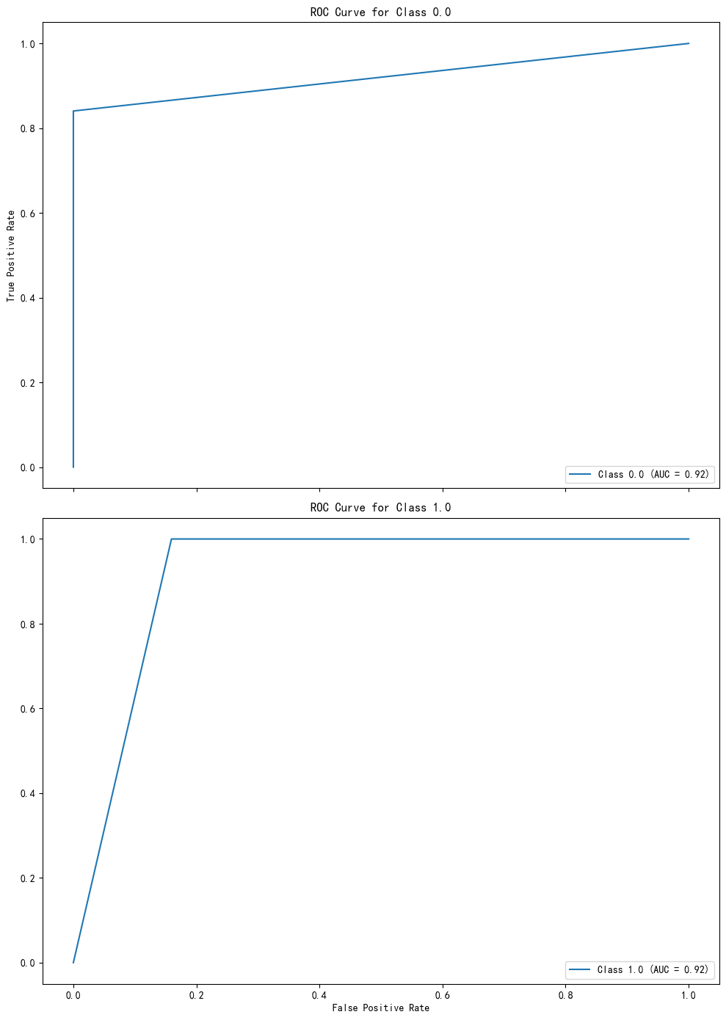
图 42 ROC curve
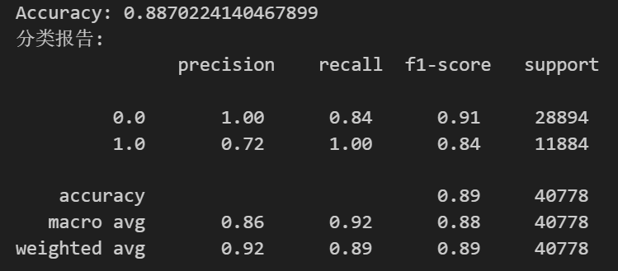
图 43 Adaboost result

2.3.3 Model Evaluation and Performance Analysis
After evaluating the above five models, the calculated accuracies of all five are relatively high . Logistic Regression and AdaBoost have the highest accuracy.
- # Add your code here for comparing your models. Describe in the markdown below why the model you chose is the best model.
- # 定义模型
- models = {
- "Logistic Regression": log_reg,
- "Random Forest": rf_model,
- "LDA": lda,
- "AdaBoost": ada,
- "KNN": knn
- }

- # 评估模型
- for name, model in models.items():
- scores = cross_val_score(model, X, y, cv=5, scoring='accuracy')
- print(f"{name} Accuracy: {np.mean(scores):.2f} (+/- {np.std(scores):.2f})")
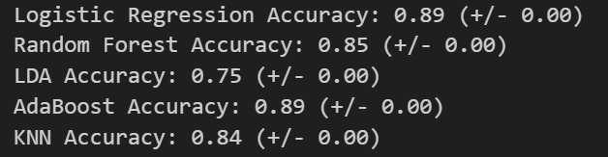
图 44 Model comparison

